COVID-19
Club Guide

Version 7 - 1 October 2020

Table of Contents

1 Introduction 3
2 Current Restrictions 4
2.1 Future Directions and Roadmap 5
2.2 Re-Opening Process for Clubs 8
2.3 Other helpful returning to sport resources 8
3 Communication 9
4 Helpful Links 9
4.1 Government and State Sporting Associations 9
4.2 Financial Support 9
4.3 Keeping fit at home 10
5 Operations 10
5.1 2020/21 Summer allocations 10
5.2 Membership and Registration Payments 11
5.3 Annual General Meetings 11
5.4 Holding Club Meetings 12
5.5 Liquor Licence 12
5.6 Player and Member Engagement 12
6 Suggestions for Future Planning: 12
6.1 Club Health Check 13
6.2 Financial Management 13
6.3 Club Structure 13
6.4 Risk Management 13
6.5 Healthy Clubs 14
6.6 Marketing 14

Introduction

In line with the State Government’s latest directions, Council has developed a COVID-19 Safe Guide for clubs.

Clubs have an important role to play in getting people to return to sport and activity, and protecting the wider community through social distancing and increased hygiene practices.

Below are some suggested tools and general guidance (or information) that is aimed at supporting you and your club.

If you require assistance from Council regarding facility usage or other general club support, please contact:

William Bullock (Leased clubs)
Recreation Officer
Phone: 9278-4783
William.bullock@boroondara.vic.gov.au

Verity Wignall (Leased clubs)
Recreation Officer
Phone: 03 9278-4797
Verity.Wignall@Boroondara.vic.gov.au

Sean Buncle (Seasonal/licenced clubs or groups)
Sports Liaison Officer
Phone: 03 9278-4035
Sean.Buncle@boroondara.vic.gov.au

Current Restrictions

Below is information and advice regarding what you can and cannot do under the current Victorian Government COVID-19 restrictions.

The information is based on the latest information from the Department of Health and Human Services, which can be found via the following link

https://www.dhhs.vic.gov.au/stage-4-restrictions-covid-19

Check 5km Radius from Home Here

Metropolitan Melbourne is now under Stage 4 Restrictions This means that unfortunately no community sport or use of outdoor sport and recreational facilities will be allowed until further notice. All facilities with Council managed access systems will be locked.

Maintenance

Under the DHHS guidelines (see link), clubs can access their facilities for required maintenance only. Prior to doing this, you will need to make sure of the following:

- Access is covered in your COVID safe plan and all necessary measures are followed.
- The maintenance is required to be done to keep the facility ticking over during lockdown eg it’s not reasonable to visit your facility to put up some new shelves.
- At this stage we have no specific advice from DHHS about whether the 5km limit applies. Our advice is to ensure people attending for maintenance are not travelling more than 5km where at all possible. Use the link above to help determine the 5km radius from your club.

Please see the following link for some info re turf management during COVID-19 and we also encourage you to reach out to your suppliers about how you can reduce maintenance as much as possible.

Please also ensure you make contact with us if you need Council to arrange pavilion access, under the conditions noted above.

Future Directions and Roadmap

Return to Sport Roadmap

Steps | First Step | Second Step | Third Step | Last Step | COVID Normal
Date | 11.59pm on 13 September 2020 | Later of threshold being met and 28 September 2020 | Later of threshold being met and 19 October 2020 | Later of threshold being met and 23 November 2020 | When threshold met
Tennis Clubs | Closed | Closed | Return to Play - and Coaching Restrictions in place.  Gathering and density limits. | Return to Play - Facilities open subject to safety measures  Limitations on spectators | No restrictions on community sports or spectators
Bowls Clubs/Petanque/Croquet | Closed | Closed | Return to Play  Restrictions in place.  Gathering and density limits. | Return to Play - Facilities open subject to safety measures  Limitations on spectators | No restrictions on community sports or spectators
Rowing | Closed | Closed | Return to Play  Restrictions in place.  Gathering and density limits. | Return to Play - Facilities open subject to safety measures  Limitations on spectators | No restrictions on community sports or spectators
Indoor Activities/ Weightlifting/HCYC | Closed | Closed | Closed | Return to Play - Facilities open subject to safety measures  Organised contact sports resume for all ages  Limitations on spectators | No restrictions on community sports or spectators
Hockey | Closed | Closed | Return to Play  Restrictions in place.  Gathering and density limits. | Return to Play - Facilities open subject to safety measures  Limitations on spectators | No restrictions on community sports or spectators
Cricket | Closed | Closed | Restrictions in place for Pavilion/Change rooms. Contact and non-contact sport for U18.  Non-contact sport for over 18  Gathering and density limits. | Return to Play - Facilities open subject to safety measures  Organised contact sports resume for all ages  Limitations on spectators | No restrictions on community sports or spectators
Athletics | Closed | Closed | Restrictions in place for Pavilion/Change rooms. Contact and non-contact sport for U18.  Non-contact sport for over 18  Gathering and density limits. | Return to Play - Facilities open subject to safety measures  Organised contact sports resume for all ages  Limitations on spectators | No restrictions on community sports or spectators
Netball | Closed | Closed | Restrictions in place for Pavilion/Change rooms. Contact and non-contact sport for U18.  Non-contact sport for over 18  Gathering and density limits. | Return to Play - Facilities open subject to safety measures  Organised contact sports resume for all ages  Limitations on spectators | No restrictions on community sports or spectators
Baseball | Closed | Closed | Restrictions in place for Pavilion/Change rooms. Contact and non-contact sport for U18.  Non-contact sport for over 18  Gathering and density limits. | Return to Play - Facilities open subject to safety measures  Organised contact sports resume for all ages  Limitations on spectators | No restrictions on community sports or spectators
Ultimate Frisbee | Closed | Closed | Restrictions in place for Pavilion/Change rooms. Contact and non-contact sport for U18.  Non-contact sport for over 18  Gathering and density limits. | Return to Play - Facilities open subject to safety measures  Organised contact sports resume for all ages  Limitations on spectators | No restrictions on community sports or spectators
Soccer | Closed | Closed | Restrictions in place for Pavilion/Change rooms. Contact and non-contact sport for U18.  Non-contact sport for over 18  Gathering and density limits. | Return to Play - Facilities open subject to safety measures  Organised contact sports resume for all ages  Limitations on spectators | No restrictions on community sports or spectators
Winter pre season | Closed | Closed | Restrictions in place for Pavilion/Change rooms. Contact and non-contact sport for U18.  Non-contact sport for over 18  Gathering and density limits. | Return to Play - Facilities open subject to safety measures  Organised contact sports resume for all ages  Limitations on spectators | No restrictions on community sports or spectators

Re-Opening Process for Clubs

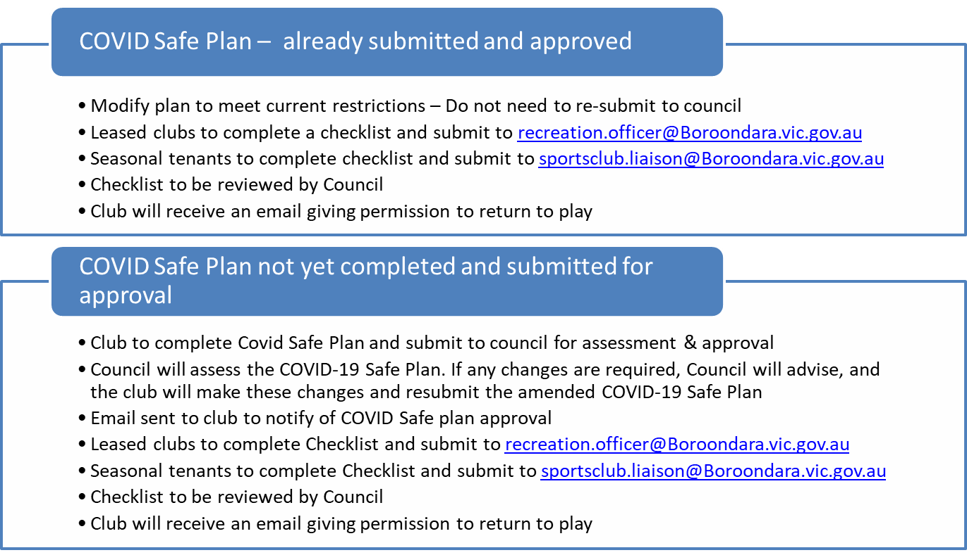

Other helpful returning to sport resources

Sport Australia has provided some principles and information (including some resources) to help clubs prepare for a return to sport, when the time comes. These are important documents, but must be read in conjunction with information from the Victorian Government

AIS framework for re-booting sport:
https://ais.gov.au/__data/assets/pdf_file/0008/730376/35845_AIS-Framework-for-rebooting-sport_FA.pdf

AIS toolkit for returning to sport:
https://www.sportaus.gov.au/media_centre/news/toolkit-launched-to-help-guide-return-of-community-sport

FAQs
https://www.dhhs.vic.gov.au/victorias-restriction-levels-covid-19

VicSport also has some useful COVID-19 related information, including a series of club development webinars: link

Safe Site Register for Clubs - QR Code
https://www.visitsafe.at/faq

Communication

- It is really important for Clubs to ensure information is available for members and stakeholders during this time and keep them well informed of updates from Council.
- Your state sporting body and or association/league policies and statements may be useful to reference when communicating with members and stakeholders

Helpful Links

Government and State Sporting Associations

Sport and Recreation Victoria - State Sporting Associations

COVID Safe-App

Department of Health and Human Services COVID 19

AFL Victoria - Return to Play

Athletics Victoria

Archery Victoria - Return to Play

Baseball Victoria - Covid-19 Updates

Bowls Victoria

Croquet Victoria

Football Victoria

Hockey Victoria

Lacrosse Victoria

Netball Victoria - COVIC 19 Information

Rugby Victoria - COVID 19 Updates

Tennis Victoria

Financial Support

Given the current COVID-19 pandemic, Council has been considering a number of ways to assist community groups that have been impacted.

We are aware that sports clubs within Boroondara have been significantly impacted by COVID-19 for a number of reasons, including lost revenue from reduced membership fees, reduced game day takings (BBQ, canteen sales, club shops etc.) and the loss of sponsorship money. We also understand that clubs will see increased expenses, including for additional cleaning and hygiene practices as you get back up and running.

As you are aware, the City of Boroondara is already assisting clubs by freezing lease and licence payments for a period of time. Winter season allocated clubs have had their 2020 fees waived this season regardless of whether matches and training returns this season. In addition to the above, the Victorian Government’s let’s stay connected’ scheme may be of interest: https://www.suburbandevelopment.vic.gov.au/grants/lets-stay-connected

Vic Sport has also compiled a list of a range of grants that clubs can access at the moment. See - link

Please reach out if you want support in submitting grant applications

Keeping fit at home

Please see below links to some great free workouts provided by The Body Coach TV.

10 Minute Home Chair Workout for Seniors
Link here

5 Minute Move - Kids Workout 1
Link here

20 Minute FULL BODY Home HIIT
Link here

Operations

2020/21 Summer allocations

In line with the current Victorian Government’s COVID-19 restrictions, training and matches are not permitted to occur for community sporting clubs. These restrictions are in place from 2 August 2020 and it is hard to predict how any future restrictions will impact the upcoming 2020-21 summer season. Clubs and groups will however, be able to submit their 2020/21 summer allocation in preparation for the upcoming season.

The seasonal application process on IMS will open for the 2020-21 summer season on Monday 3 August 2020 and will close on Monday 31 August 2020.To maximise the efficient use of council grounds, Council will be working with the relevant associations to ensure allocated grounds are being utilised accordingly.

We will work closely with our summer sporting clubs and groups to ensure you can transition back into your facilities as well as training and matches in line with the Victorian Governments ‘return to play’ requirements.

Membership and Registration Payments

This topic is one of great debate and confusion among Clubs at the moment.
There is no set answer to how this situation should be treated.
The below items may help the Club make an informed decision around financial impacts of registration and membership payments. It will be important to ensure the Club is clear with members around the approach and process you undertake to make these decisions.

Things to consider:

- Consider the length of time members will be without their member benefits.
- Review your membership policy and terms and conditions.
- Is pro rata membership a possibility?
- Consider a special offer to members who do pay their membership this year.
- City of Boroondara Individual Participation Grants to assist people in paying registration/membership fees. For further information or to apply click here.

Annual General Meetings

The current coronavirus pandemic (COVID-19) has many community clubs and organisations rethinking their Annual General Meeting (AGM) arrangements for 2020. Below is some helpful information that may assist clubs with AGMs

- Virtual AGMs

A virtual AGM is a meeting that allows members to attend, vote and ask questions at the AGM through an online platform. The Association Incorporation Reform Act 2012 (Vic) permits AGMs to be conducted using technology, providing every person can hear and be heard. This is regardless of what is written in the organisations constitution, or rules about AGM meetings.

- AGM Extensions

In Victoria, Incorporated Associations must hold their AGM within five months of the end of their nominated financial year. Consumer Affairs Victoria may grant three month extensions for holding AGMs in exceptional circumstances, including due to COVID-19. Organisations can apply for an extension through Consumer Affairs Victoria. If organisations are finding it difficult to engage an independent accountant or auditor to review their financial statements due to COVID-19, they can also request an extension to delay the submission of their financial statements via the following link.

- For information about delaying or hosting AGMS online please click here

- The Institute of Community Directors Australia has also produced a helpful guide with answers to some frequently asked questions.

Holding Club Meetings

- Meetings can be held over the phone and/or via video conference call. Depending on the numbers of people you may need to use online platforms.
- Zoom is a free video conference website which can be used for online meetings up to 40 minutes: https://us04web.zoom.us/
- There are other platforms also available such as FaceTime, Skype, Teams, phone video chat, Facebook chat, etc.

Liquor Licence

- VCGLR are offering support to clubs during this period.
- VCGLR are waiving fees and or refunding all 2020 liquor licence payments. Find out more details here: https://www.vcglr.vic.gov.au/news/2020-liquor-licensing-fees-refunds-and-waivers

Player and Member Engagement

Encourage and source ways for members and players to stay engaged. For example use of social media apps: Team App, WhatsApp, Zoom, Facebook chats, closed Facebook groups.
Ideas:
- Player/member interviews: Ask members the same 10 questions, video answers (publish in team chats, or on social media)
- Competition for people to upload funny videos. Always gain permission from members before doing so.
- Visit state/national body website and social media for ideas.
- Ask the members what they would like to see. Obtain their feedback on future events, programs, services, ways to engage, training suggestions etc.
- Home training ideas from State and National sporting bodies:
https://vicsport.com.au/blog/3530/how-sports-are-handling-covid-19

Suggestions for Future Planning:

This could be a great time to start planning and putting in place policies and procedures that may assist your club in the future. A club health check is a great way to start and build on your current position. A club health check should identify ways to improve your Club based on the questionnaire. If you don’t have a business plan and or strategic plan, this should first be developed before moving onto other items.

Club Health Check

- This is a great time to conduct a Club health check. Many state sporting bodies have these, and there is also one available from Aus Sport. The best option is usually your state body’s health check as they are relevant to your sporting code.
- Included in your Club health check, there should be some key outcomes that the clubs can work towards.
- Before the facilities fully reopen, this could help the club identify gaps in operations to help cement future club success.

Sport AUS Club Health Check: https://www.sportaus.gov.au/club_development

Financial Management

- Not only is it important to figure out the club’s financial status during the closure, it is also important to look into future planning and budgets.
- Most state sporting bodies and associations will be able to assist with this. They can give clubs a good idea of required sinking funds needed and what a healthy budget looks like.

Club help: https://www.clubhelp.org.au/club-finances

Club Structure

- This could be a good time to optimise your club structure. Are you missing key roles? Are people more suited to alternative roles? Do some roles require more support?

Club help: https://www.clubhelp.org.au/club-management/committee

Risk Management

- Have you given much consideration to your risk management? Who looks after this?
- This could be a great time to look into risk management. Some items may not be able to be carried out, however many will still be able to be completed.

Club help: https://www.clubhelp.org.au/club-resources

Healthy Clubs

- Is your club a Healthy Club? This could be in regards to many different items such as; child safety, gender equality, alcohol management, safe sport, etc.
- This could be a good time to review policies and culture within the club.

Club help: https://www.clubhelp.org.au/healthy-clubs

Marketing

- Does your club have a marketing plan? This could be a great time to develop one.
- Consider currently the only way you can connect with your members and stake holders is through marketing. Without a marketing plan it would be hard for a club to work in these current times.
- Marketing is a vital part of club success for both current stakeholder and potential stake holders.

Club help: https://www.clubhelp.org.au/marketing

We thank you for your understanding during these trying times.

